Hardware Unit Test Report

TYPE2542 HW Test
Hardware version | FW version | Manufactory P/N
V025 | 4.9.113 #71 wed Jul 15 13:23:10 CST 2020 | TYPE2542

- Power Test Setup

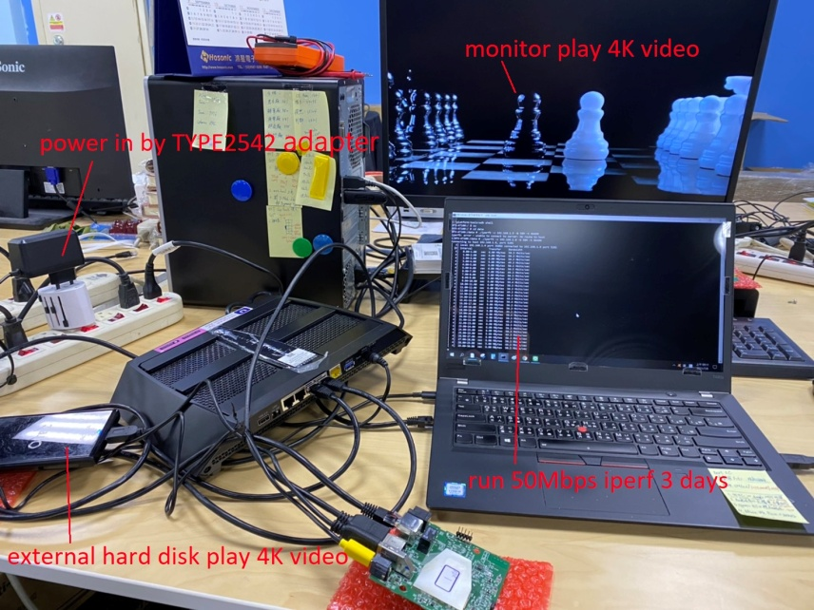

  - Test Condition
．BOX play 4K video by using external hard disk.
．Ethernet is connected to AP WIFI and run iperf base on 50Mbps to server.
．HDMI output port connects to TV through the HDMI cable.
．DC Power cable is also connected.
．The temperature is about 25 degrees. The results are meeting +/-5%.

  - Test Item
．Power accuracy
．Power ripple
．Stress

  - Result and Picture
Power Rail | Specification (V) |  |  | Test Result (V) | Figure | Pass/Fail
Power Rail | Power Accuracy |  |  | Test Result (V) | Figure | Pass/Fail
Power Rail | Min. | Typ. | Max. | Test Result (V) | Figure | Pass/Fail
PP_PWR_IN (5V) | 4.75 | 5 | 5.25 | 5.015 | Figure 1 | Pass

Power Rail | Specification (+/-5%) | Test Result (mV) | Figure | Pass/Fail
Power Rail | Max Ripple (mV) | Test Result (mV) | Figure | Pass/Fail
PP_PWR_IN (5V) | 250 | 92 | Figure 2 | Pass
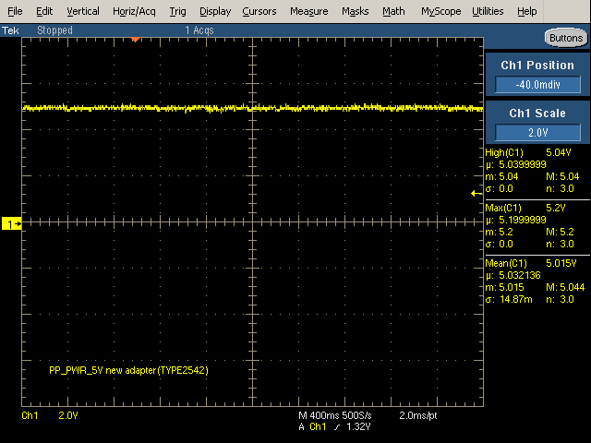 | 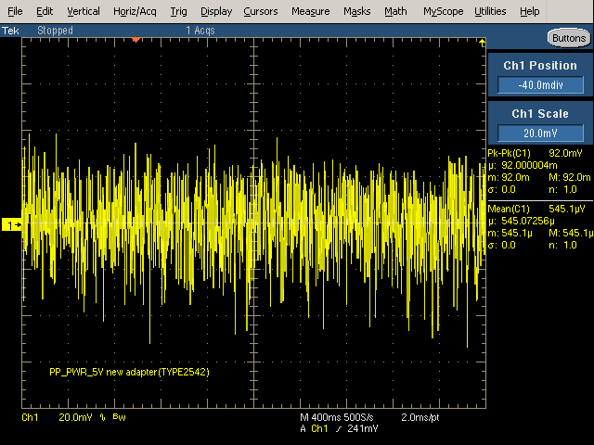
Fig. 1: PP_PWR_IN (accuracy) | Fig. 2: PP_PWR_IN (ripple)

1.4 Stress test
Apply above test environment, and run iperf for three days, verify that TV is still playing 4K video and iperf is running too.
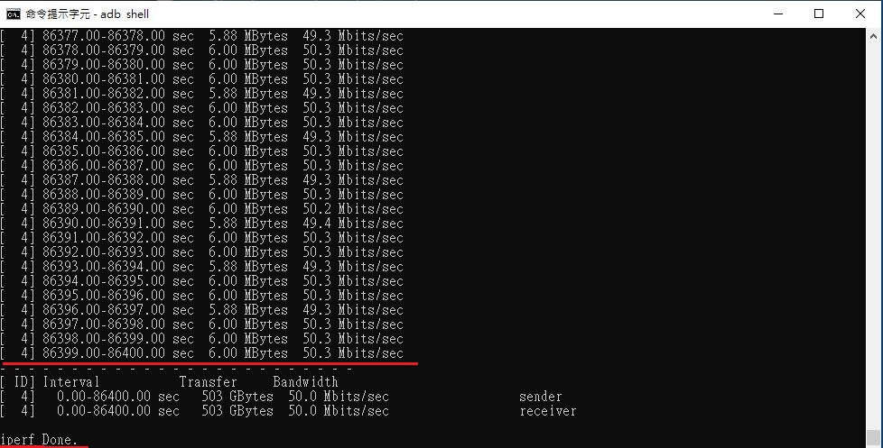
1.5 Conclusion
After 3 days of testing, video and iperf still running, conclude the TYPE2542 stress test is PASS.
 | Stress test
TYPE2542 | PASS

